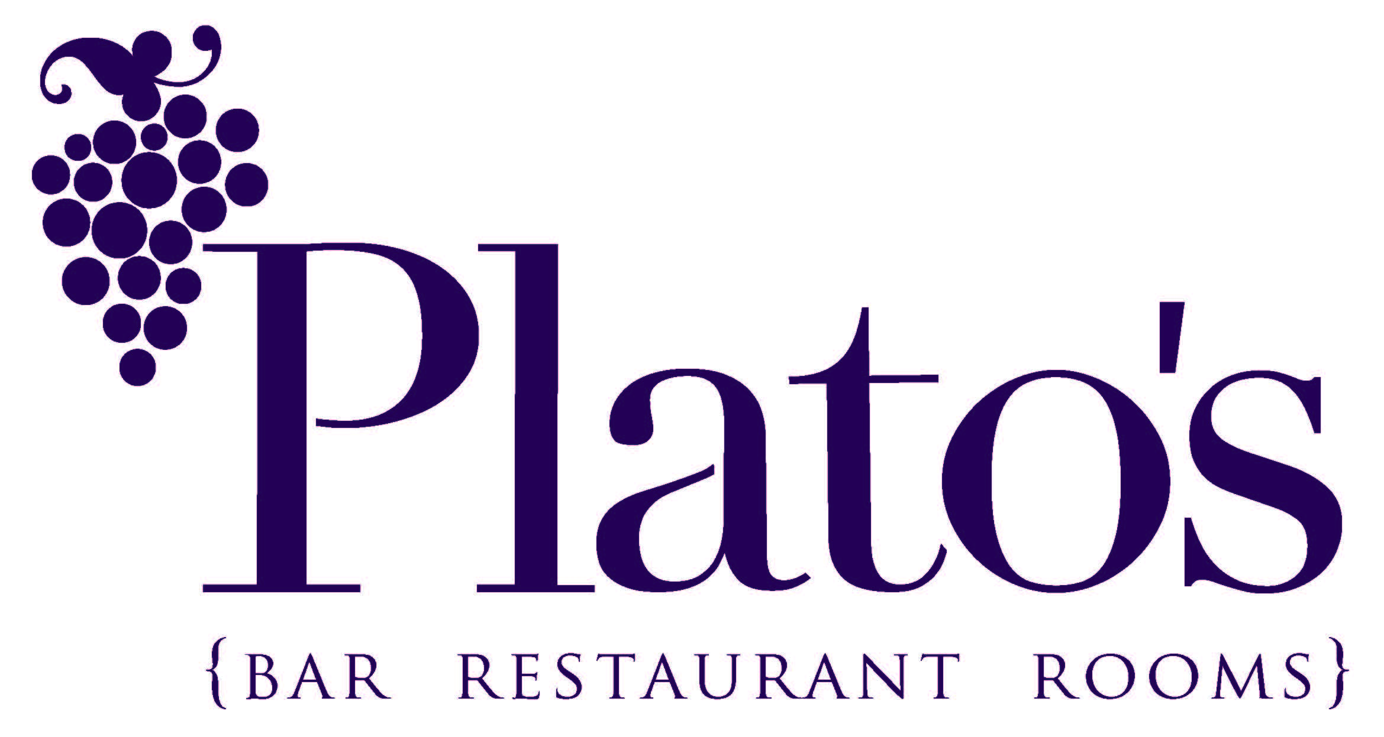

House Cocktails

Espresso Martini £9.00
Absolute Vodka, Mr Blacks coffee liqueur, espresso
Mojito £9.00
Havannah 7, sugar, mint, lime
Salted caramel Pornstar £8.50
Absolute Vanilla,
passionfruit, lemon, salted caramel

Old Fashioned £9.50
Woodford Reserve, sugar, bitters, orange
French Martini £8.50
Absolute Vodka, Chambord, pineapple
Rhubarb Negroni £8.50
Rhubarb & Raspberry Gin, Aperol, sweet vermouth Aperol Spritz £8.50 Aperol, Prosecco, soda, orange

Plato’s SOUR £8.50
Pisco, sugar, lime, egg white
Tom Collins £8.50
London Gin, Lemon, Soda £8.50
French 75 £8.50
Prosecco, Tanqueray 10, lemon, sugar

Cosmopolitan £8.50
Absolute Vodka, Cointreau, lime, cranberry
ELDERFLOWER BELLINI £8.00
St Germain, Prosecco,
cloudy apple juice, mint
Bramble £8.50
Tanqueray 10, lemon,
Crème de Muir

