Menu
Appetizers
Marinated olives {ve} 4.00
Seasons Bakery Sourdough, aged balsamic, flavoured butter {v} 7.00
Starters
Soup of the day, seasons sourdough, salted butter {v} 6.50
Steamed mussels, smoked bacon, parsley, and Guinness cream sauce 9.00
Sticky Korean BBQ duck, blood orange & shallot salad, vermicelli noodles 9.00
Cumbrian ham hock terrine, homemade pickles, tomato & red pepper ketchup, sourdough 8.50
Trout & salmon fishcake, braised baby gem, warm tartar sauce, crispy potato 7.50
Whipped goats’ cheese, pickled beetroot, pomegranate dressing {v} 7.50
Mains
Lamb rump, pomme dauphine, pea & broad bean fricassee, minted pea puree, lamb jus 28.00
Loin of pork, braised cabbage & bacon, pomme anna, caramelised red apple 18.00
10oz Cumbrian sirloin, field mushroom, confit plum tomato, triple cooked chips, peppercorn sauce 30.00
Hake loin, spiced chickpeas, rock samphire, chorizo, lemon & chilli butter 19.50
Chicken breast, chicken leg croquette, spinach gnocchi, charred broccoli 18.00
Beetroot wellington, pickled walnut ketchup, glazed roast carrots, whipped potato {ve} 16.00
Roast butternut squash and sage risotto, crispy kale, toasted pumpkin seeds {v} 15.00
Sides
Honey roast carrots 4.00
Seasoned greens 4.00
Tenderstem broccoli and almonds 4.00
Celeriac mash 4.00
Colcannon creamed potato 4.00
Hand cut chips 4.00
All our meat is responsibly sourced from outdoor bred livestock
All prices include VAT at current rate
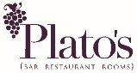  Allergens | Starters |  |  |  |  |  | Mains |  |  |  |  |  |  | Sides
 | Soup | Mussels | Terrine | Fishcake | Duck | Goats Cheese | Lamb | Sirloin | Pork | Chicken | Cod | Beetroot | Butternut Squash | Chips | Broc & almonds | Carrots | Seasoned Greens | Celeraic Mash | Colcannon Mash
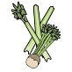Celery
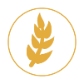  Cereals containing gluten** | W | W | W | W |  |  |  |  |  | W |  | W
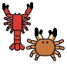
Crustations
Eggs
Fish
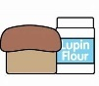
Lupin
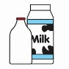
Milk
Molluscs
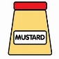
Mustard
Nuts*
Peanuts
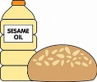
Sesame Seeds
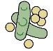
Soya
Sulphur Dioxide

